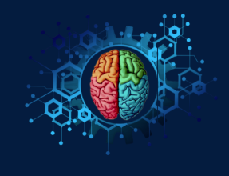
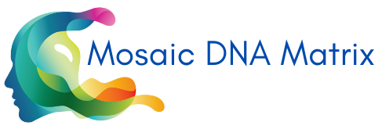
You are not your brain.
Learning to let your brain lead your way results in career and life decisions becoming easier and achieving peak performance.
Here are a few brain-based principles:
Everyone has a set of natural behavior preferences (career DNA), every job has its behavioral demands (job DNA), when the two-match satisfaction, motivation and fulfillment occur and job performance peaks. People don’t become engaged in their work, it’s the brain that engages.

- Through neuroscience assessment there is no labelling or categorizing as being one thing or another. The remarkable complexity of the brain has shown that human beings cannot credibly be divided up into a fixed number of types or groups of people who are unable to act outside of their preferences. Everyone has a range of preferences, some very high, some very small, some moderate. It’s the composition that makes us each unique.

- Skills do not predict performance, or success in a job role. Ask any HR professional, people with the same skills in the same job perform at different levels. Something else is at play. Skills application is contextual. Behavior is what powers performance, and all behavior is brain-based.

- When the job calls on the behaviors generated through the most developed circuitry in the brain, the brain is working at its most optimal state, free from stress. However, when the brain must activate behaviors less well developed, the brain consumes more energy, it must work harder, which leads to mental and physical fatigue.
- Based on behavior fit to a job (which means brain fit) some jobs are healthy; many jobs are unhealthy. When forced to adapt behaviors and operate outside the brain’s natural state, this is called ‘falsification of type’ which creates occupational stress. It’s the difference between a happy brain and an unhappy brain, a healthy job and a happy brain is at the root of mental wellness in the workplace.

- There will be significant changes to jobs and many new jobs to consider. Up-skilling and re-skilling will be required. Understanding behavior preferences helps navigate the significant disruptions throughout one’s work life.

- The brain changes every day (it’s called neuroplasticity). Intentional behavior development is the efficient way to professional development. It’s much easier to learn new skills and undertake change when it’s approached as behavior change. Behavior change creates change in the brain.

- The fundamental role of the brain is our survival. The brain constantly detects threats. When under pressure for performance, the brain goes into a protective state, the most developed circuitry goes into overdrive, very high behavior preferences become overdone, affecting communication, relationships, and productivity. Understanding one’s very high preferences and being consciously aware when under pressure mitigates this outcome.

- Behavior preferences dictate learning preferences, understanding how the brain likes to learn makes learning easier and efficient. Learning is an essential trait for success in the workplace.
- Nine out of ten most in-demand skills are behavior-based, such as analytical thinking and self-awareness, these in-demand skills will come naturally to everyone, knowing which ones is the foundation to performance and a fast start to a new career.
- The brain does not like change which is why people dislike work-based change, and many change programs fail. The brain is a pattern-making organ, when the daily patterns get disrupted, the brain must work harder, we experience discomfort. Knowing this makes change easier, less stressful because it’s our comfort zone that’s being tested, and pushing against comfort zone is the essence of personal development.
- Being aware of the brain’s signals increases self-awareness, a key attribute of successful people, because job performance is more productive when in touch with self (and not everyone is). Self-awareness is a top ten in-demand skill.
- Creativity is derived from behavior preferences. Creativity is no longer the realm of a lucky few, if you have a brain, you have creativity. knowing creative preferences enable creative thinking, a key requirement from business leaders.
- Work culture has a significant influence on job performance. The same job in two different work cultures calls for different preferences. Matching the brains preferences to work culture is how to find the employers where one will perform the best.

About PRISM
PRISM Brain Mapping is a unique way of identifying people’s behavior preferences based on brain activity. Unlike traditional psychometric instruments, PRISM approaches human behavior from the perspective of neuroscience, rather than psychological theory. This exciting online tool takes advantage of some of the most up-to-date neuroscience discoveries to provide users with a series of ‘maps’ which are representations of how their brain prefers to work.

